**An Analysis on Mark-18A Target Irradiation History and Inventory of Plutonium and Heavy Curium**

Benjamin Austin, W. Cade Brinkley, Jennifer Jeffcoat, Jacob Weinberg, Benjamin Beeler

**Abstract**

From 1969 to 1979, the Savannah River Site (SRS) produced and managed heavy isotopes as directed by the DOE. This was accomplished by exposing 86 highly enriched Pu-242 Mk-18A Outer Housing (OH) targets to heavy neutron fluxes in the K-Reactor, with the initial intent to produce Cf-252. Although this directive was abandoned just over a year later, the Plutonium targets continued their exposure in an effort to produce Pu-244 for the duration of the decade. After decommissioning, 21 of the targets were transferred to Oak Ridge National Laboratory (ORNL) to extract the accumulated Cf-252. The remaining 65 Mk-18A targets remained in water basin storage located at Savannah River Site. The purpose of this study is to model the irradiation history of the core and the decay of isotopes to approximate the inventory of each individual target. These approximations have been made but with low precision, separating the targets into 3 different groups. By modeling each target individually, a more precise estimate can be made to determine which target to process first.

**Introduction**

The high flux Californium I irradiation campaign began August 11, 1969, and ended November 8, 1970. During this time, 86 Mk-18A targets with high enriched Pu-242 were exposed to a high amount of neutron flux in an effort to produce Cf-252. Californium is a synthetic radioisotope produced in reactors via multiple neutron capture reactions, which is a highly sought after neutron source. With a half-life of 2.6 years and a 3% natural fission decay rate, it has uses in medicine, reactor startup, metal detectors, etc. There are only 2.625 grams of Cf-252 produced annually worldwide. u, in that t

|  |
| --- |
|  |
| *Figure 1: Production chain of Californium 252 from Uranium 238* |

Between 1972 and 1973, 21 of the 86 Mark 18-A targets were processed to recover Cf-252, heavy curium, and plutonium. The extraction of these isotopes was applied to industrial applications and the discovery of new superheavy elements. Savannah River Site currently houses the majority of the world’s heavy curium and plutonium in the remaining 65 targets. The supply of these isotopes is low compared to the high demand and is expected to deplete by 2030.

In 2012, Savannah River Site was appointed to address the disposal or recovery of the remaining 65 Mark 18-A targets. The target of the examination was to distinguish possible choices for feasible alternatives, assess every choice versus automatic needs, and suggest dispositioning choices for the materials. The study assessed seven alternatives for the attitude of the Mark-18A: five unique choices for recuperation of the materials for some time later, a fractional recuperation choice, and a possibility for the manner of the Mark-18A material as waste. The investigation prescribed that the Mark-18A targets be handled to recuperate the essential Pu-244 and overwhelming curium and move the materials to ORNL for capacity and future advantageous use.

In this work….

**Core Design**

The K-reactor core consists of a hexagonal lattice of annular driver assemblies as shown in figure 2. It is cooled/moderated with heavy water, and it’s 6 coolant loops help facilitate high neutron fluxes; ideal for isotope production.

|  |
| --- |
|  |
| *Figure 2: Face Map of the K-reactor located at SRS* |

**Computational Methods**

Many design specifics of the K-reactor are classified. The enrichment of the drivers, geometry of the assemblies, peaking factors, fuel to moderator ratio, and other parameters that are necessary when modeling a full reactor core can only be known to a best estimate using declassified material. Because of this, irradiation histories were modeled one assembly at a time in an effort to mitigate any sources of error that may propagate throughout the model. A consequence of this method is the need to develop a flux distribution function. This was achieved assuming a sinusoidal radial distribution, a radial peaking factor of 1.35, and equations 1 and 2:

|  |  |
| --- | --- |
| $$q(r)=q_{0 }cos(r)$$ | (1) |
| $$F_{r}=\frac{q_{0}}{\frac{1}{πR^{2}}\int_{0}^{R}{}2πrq(r) dr}$$ | (2) |

Since the dimensions of the core were unknown and the placement of the targets was provided in cartesian coordinates, the x and y indices were utilized (and normalized to $π/2$) resulting in equation 1 becoming:

$$q(x,y)=q_{0}cos(\sqrt{x^{2}+y^{2}})$$

And equation 2 becoming:

$$F_{x,y}=\frac{q_{0}}{\frac{1}{π}\int_{-2}^{1}{}\int_{-\sqrt{1-x^{2}}}^{\sqrt{1-x^{2}}}{}q(x,y) dy dx}$$

Figure 3 shows the general shape of the flux profile using this method:

|  |
| --- |
|  |
| *Figure 3: Presumptive shape of the K-Reactor’s flux profile with exaggerated amplitude for visualization.* |

This distribution function was utilized to assign power levels to each assembly in each cycle for the duration of the irradiation time.

|  |
| --- |
|  |
| *Figure 4: Sketches of MK-14, 16, and 22 Tubes* |

The model assumes that each assembly consists of three inner concentric uranium-aluminum alloy annuli that are 6 ft tall, referred to as the drivers (as seen in figure 4), and a single plutonium-aluminum alloy annulus, referred to as the target, around the middle four feet of the drivers. The drivers are assumed to share dimensions with 2, 2.5, and 3-inch schedule 10 aluminum pipe while the target is assumed to share the dimensions of a 3.5-inch schedule 40 aluminum pipe. Additionally, the initial amounts of the activated isotopes in the target and the amount of fuel in the three driver rings throughout their lifetimes is known. This is used to find the isotopic density of the relevant material with the known geometries as shown in equation 5.

ρ_x=m_x/V_x

**SCALE**

**Results**

Sixty-five unique input files were generated for each of the sixty-five assemblies, each with a unique flux history. The masses of specific isotopes are monitored over the lifetime of operation in-reactor, as well as after the shut-down period of the K-reactors. The shut-down period was modeled using two points of time, the first when the reactor shut down and the other 15,000 days (41.1 years) after that event. The isotopes analyzed in all SCALE tests are Cf-252, Pu-244, Cm-242, Cm-243, Cm-244, Cm-245, Cm-246, Cm-247, Cm-248, and Cm-250. Visualized plots were arranged according to clusters of isotopes that shared similar mass concentrations. Plots are on a linear-linear scale. Figures 4-8 describe the mass changes and trends of the aforementioned isotopes.

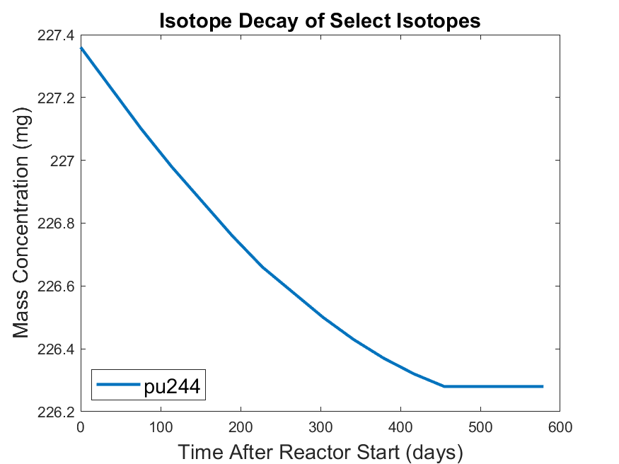

*Figure 5. Isotope Decay of Pu-244 in assembly 1*

Pu-244 is the only isotope tracked that only decreases in concentration over time. The initial mass of Pu-244 is approximately 227.4 mg, which during the operation of the reactor (days 0 - 455), steadily decreases to a minimum of approximately 226.3 mg. Figure 5 shows the briefly simulated dead time following the reactor shutdown. There is no significant change in Pu-244 concentration following the reactor shutdown on day 455. During the operation period of the reactor, there is a 0.48% decrease in the mass; considering the very large half-life of Pu-244 (T1/2 = 80 million years), it can be observed that the mass of Pu-244 will not significantly change over the reactor operation and downtime.

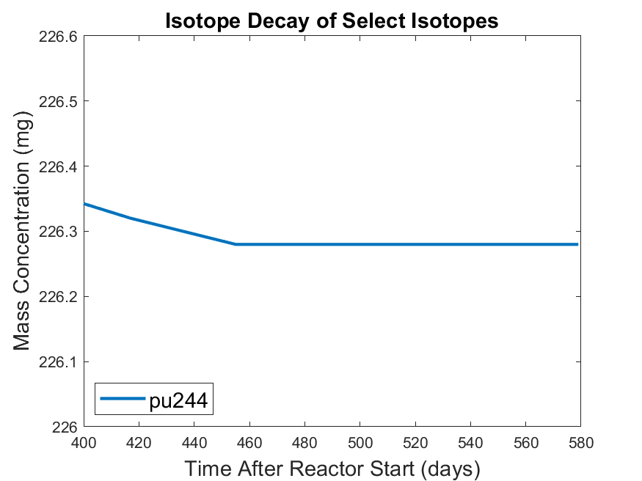

*Figure 6.*

Figures 7 and 8 show the decay of the specific curium isotopes (Cm-245, Cm-246, and Cm-248). The figures show that all of the isotopes of curium follow a similar trend, an exponential increase during reactor production which quickly becomes a flat line following reactor shutdown. Cm-248 reaches a maximum of approximately 0.2 μg after 450 days of reactor operating time.

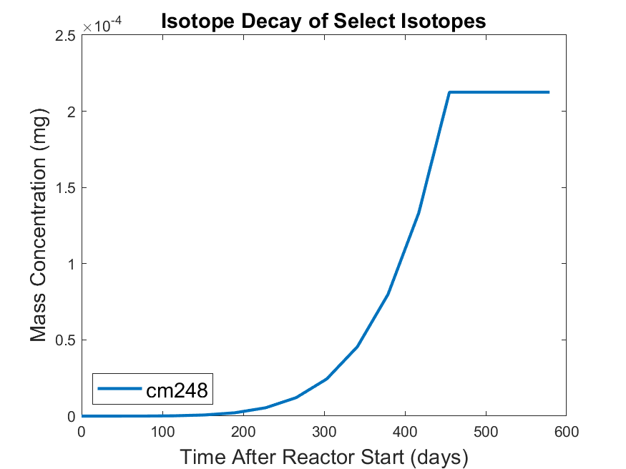

*Figure 7. Isotope decay of Cm-248 in assembly 1*

As expected, there was no initial amount of curium in the assemblies, but after reactor operation, a considerable amount of curium has been produced. It is important to note that some isotopes were produced in relatively higher concentrations. Of the tracked isotopes, Cm-250 was produced in the smallest amounts, with a maximum mass of 5 fg (on the order of magnitude of 10-15).

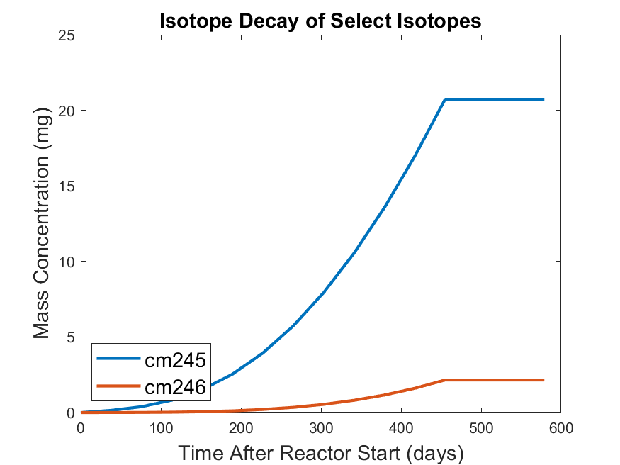

*Figure 8. Isotope decay of Cm-245 and Cm-246 in assembly 1*

Cm-245 and Cm-246 are produced in higher quantities compared to Cm-248. Compared to Cm-246, more of Cm-245 is produced during reactor operation. The maximum amount of Cm-245 is about 20 mg compared to 0.2 mg of Cm-246. Both have reasonably long half-lives (8500 years and 4760 years for Cm-245 and Cm-246, respectively) so no relevant amount would have decayed during the simulated dead time of the reactor (days 450 to 580). For a specific assembly, the SCALE results show that during reactor production Pu-244 is depleted while curium and Cf-252 are produced at an exponential rate. Following the reactor shut down, it appears that the mass concentrations of Pu-244 and curium do not change while Cf-252 quickly decays away. Further simulations modeling 20 - 50 years into the future will lend better insight into the trends within Pu-244 and curium.

**Discussion**

**Conclusion**

**Acknowledgments**

This project is supported by Dr. Tracy Stover and Ms. Tara Smith from the Savannah River National Laboratory and advised by Dr. Benjamin Beeler from North Carolina State University. SCALE was acquired through the Radiation Safety Information Computational Center at ORNL. SCALE computations are completed through the computer cluster at North Carolina State University, managed by Dr. Pascal Rouxelin.

**Work Cited**

1. SHARON ROBINSON & BRAD PATTON, *“Mark-18A Target Materials Recovery Study”,* Oak Ridge National Laboratory, 2015

2. WILLIAM P. BEBBINGTON, “*History of Du Pont at the Savannah River Plant”*, E. I. du Pont de Nemours and Company, 1990

3. WADE BICKFORD, “*Estimate of Fission Products in the Mark-18A OH Targets”*, Westinghouse Savannah River Company, 2003